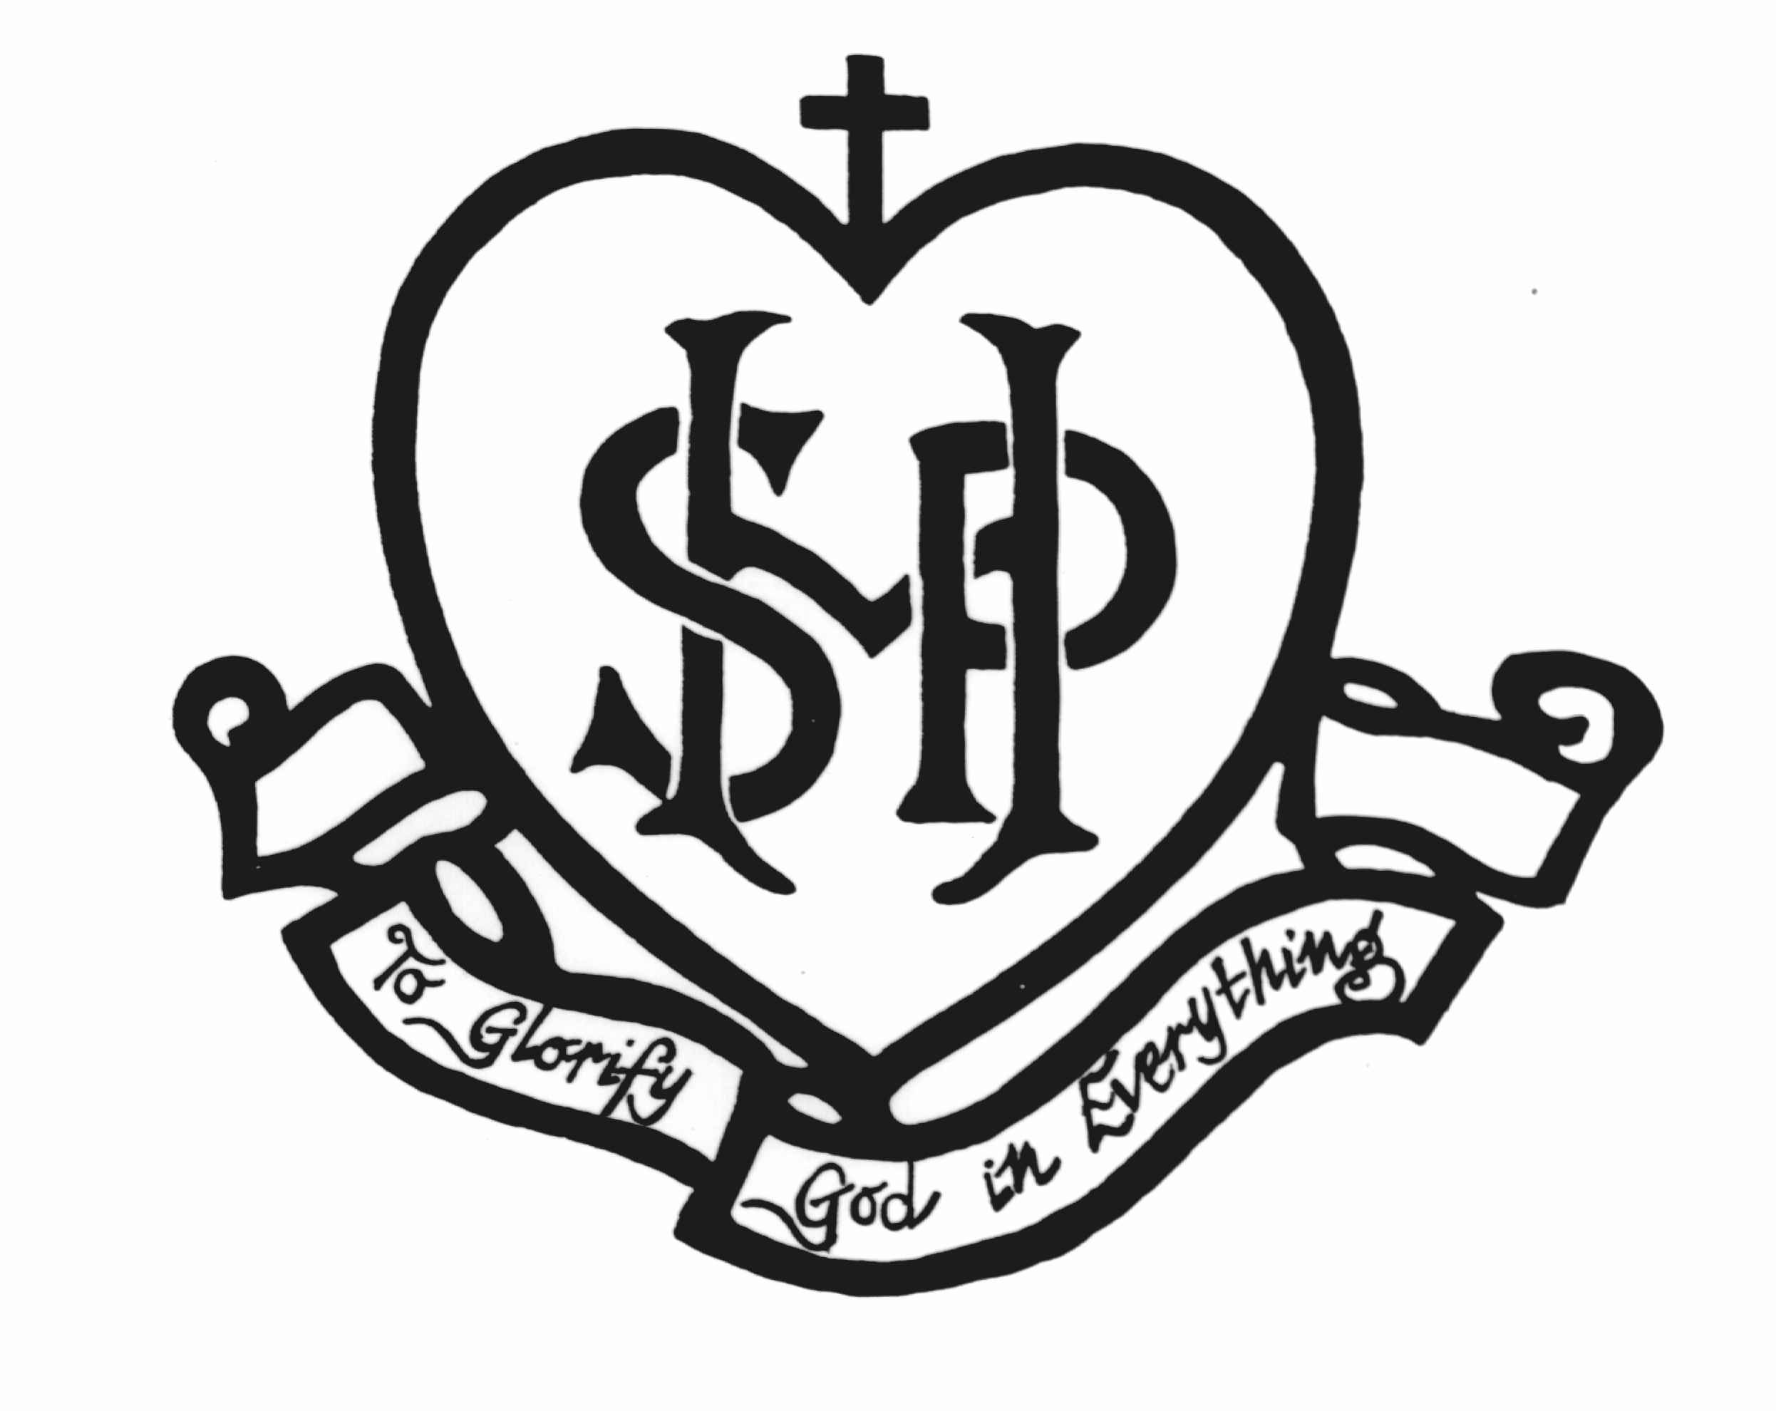

Sacred Heart School Concessional Fee Policy
Sacred Heart is a school which operates with the consent of the Catholic Archbishop of Melbourne and is owned, operated and governed by Melbourne Archdiocese Catholic Schools Ltd (MACS), where formation and education are based on the principles of Catholic doctrine, and where the teachers are outstanding in true doctrine and uprightness of life.

1. Eligibility for Concessional School Fees
1.1 The following families are strongly encouraged to apply for concessional school fees:
- Any family of Aboriginal or Torres Strait Islander heritage.
- Any family holding an HCC and eligible for CSEF.
- Any family experiencing severe financial hardship.
- Any family holding a DVA Gold Card.
- Any family identified as refugees and holding an ImmiCard.
- Any family required to relocate their (Australian resident) child to St. Michael’s Catholic Primary School, North Melbourne, due to the child requiring long term medical treatment at The Royal Children’s Hospital, Melbourne. Pro-rata concession is provided for part-year attendance. An annual statutory declaration is required to confirm eligibility.
- HSS who attend a MACS primary school on a part time basis, who meet any of the criteria detailed above.

2. Ineligibility for Concessional School Fees
2.1 FFPOS or full time HSS are ineligible for the concession as no government funding is available for FFPOS or full time HSS.

3. Concessional School Fees for Eligible Students
3.1 Students of eligible families are entitled to concessional school fees.
3.2 The school fee for eligible students is:
- 1 child – $15 per child per week, direct debit ($780 per annum or $195 per term)
- 2 children – $23 for the family per week, direct debit ($1,196 per annum, or $299 per term)
- 3 + children – $30 for the family per week, direct debit ($1,560 per annum, or
- $390 per term)
3.3 The above fees cover both tuition fees and levies.

Procedures

4. Application for Concessional School Fees
4.1 Applications for concessional school fees must be made on the Sacred Heart School approved form.
4.2 Information provided in support of concessional school fees must be treated in the strictest confidence, in accordance with the School’s Privacy Policy.

5. Successful Applications for Concessional School Fees
5.1 The Principal of Sacred Heart School is delegated the authority to approve concessional school fees,
5.2 When an application for concessional school fees is approved, an automated payment plan must be established. Where applicable, the payment plan should be set up through CentrePay or via direct credit to the School.

5.3 When invoicing families for concessional school fees, Sacred Heart School will invoice school fees and levy in full and then show a fee remission on the invoice so that the invoice total reflects the concessional school fee amount.

6. Unsuccessful Applications for Concessional School Fees
6.1 In the circumstance that a family applies for but does not meet the threshold for a school fee reduction, the Principal will work out an appropriate payment plan with the family.
6.2 Unsuccessful applications for concessional school fees are not entitled to top up grants.

